

*"Building a bridge to your dream job…!"*

# Agenda

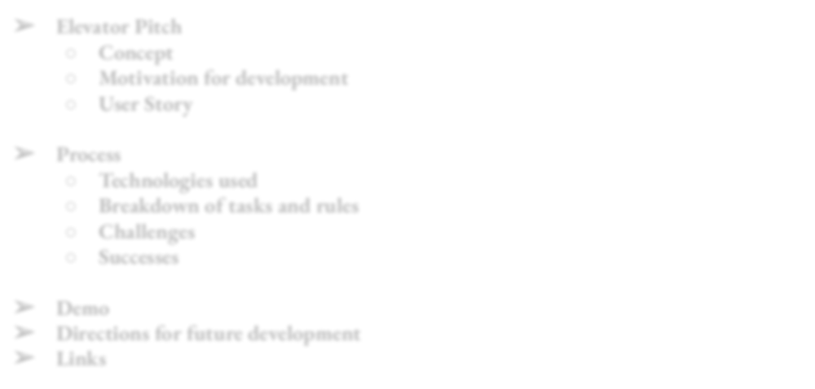

* **Elevator Pitch**
  + **Concept**
  + **Motivation for development**
  + **User Story**
* **Process**
  + **Technologies used**
  + **Breakdown of tasks and rules**
  + **Challenges**
  + **Successes**
* **Demo**
* **Directions for future development**
* **Links**

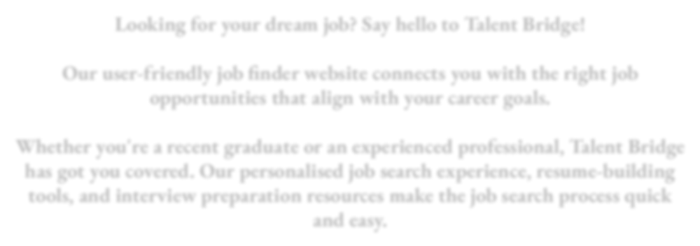

# Elevator pitch

Looking for your dream job? Say hello to Talent Bridge!

Our user-friendly job finder website connects you with the right job opportunities that align with your career goals.

Whether you're a recent graduate or an experienced professional, Talent Bridge has got you covered. Our personalised job search experience, resume-building tools, and interview preparation resources make the job search process quick and easy.

## Concept

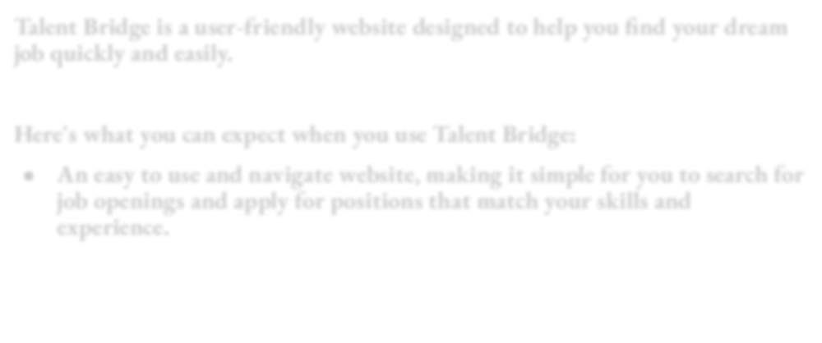Talent Bridge is a user-friendly website designed to help you find your dream job quickly and easily.

Here's what you can expect when you use Talent Bridge:

* **An easy to use and navigate website, making it simple for you to search for job openings and apply for positions that match your skills and experience.**

## Motivation for Development

***“Most people work just hard enough not to get ﬁred and get paid just enough not to quit.”*** - George Carlin

Searching for a job is never easy, we wanted to create a website that would take the pain out of the daunting task of forging a new career path.

## User Story

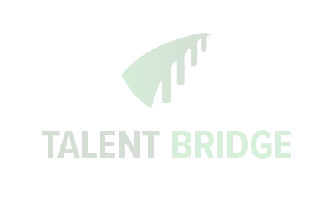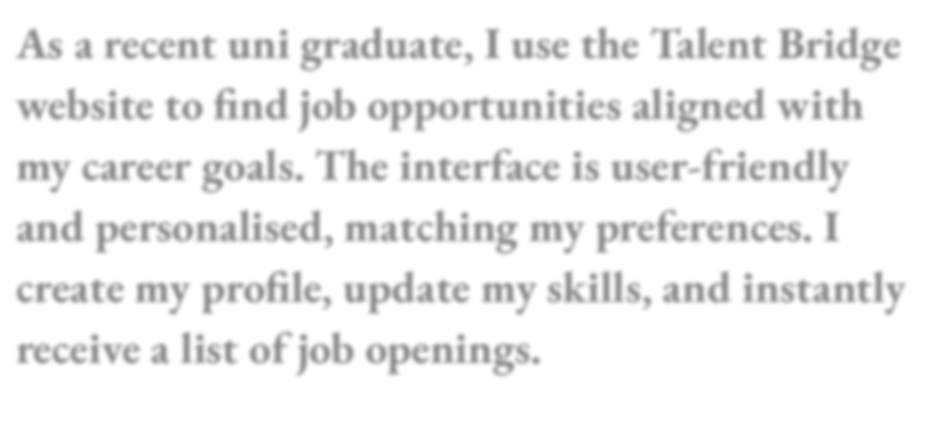

**As a recent uni graduate, I use the Talent Bridge website to find job opportunities aligned with my career goals. The interface is user-friendly and personalised, matching my preferences. I create my profile, update my skills, and instantly receive a list of job openings.**

# Technologies used

For this app, we mainly worked with Javascript, Bootstrap, Handlebars, node.js, mySQL and various npm packages, which are listed below -:

* **Express.js : used for the application server.**
* **Dotenv : used for securing database.**
* **Mysql2 : used as database connection driver.**
* **Sequelize : used for sql.**
* **Moments.js : used for time driven data**

# Breakdown of task and rules

**Talent Bridge App**

**Front - End Pages Back End Presentation Pitch**

Wireframes - All API Routes - Guy

API/Fetch calls - Sudarsh

Create a presentation

- All

Express - handlebars

- All

Javascript files - Guy, Val

Database and models

- Val & Majid

Setting up folders according to MVC - All

Heroku implementation - Guy

Connecting back end with front end - ALL

Styling with CSS & Bootstrap - Katherine



Testing the front-end - Katherine

Creating seeds - Majid

Implementing npm packages and express

Troubleshooting bugs in code - All

Resolving version control issues - All

1. **Time constraint**

# Challenges

1. **Interdependency of front and back end**
2. **Identifying the routes of User, Jobs and Categories**
3. **Tables relationships (many to many) in SQL**
4. **Learning a workflow of working in the group**
5. **Heroku deployment**
6. **Resolving Git conflicts**
7. **Styling front end pages**
8. **Reading each other code**

# Successes

**As a team we successfully:**

1. **Resolved Git conflicts**
2. **Deployed the app to Heroku**
3. **Building a working RESTFul API**
4. **Implementing handlebars given its a new technology**
5. **Troubleshooting any unexpected bugs in the code**
6. **Learning from the project and from each other**
7. **Working under pressure and communicating with each other**
8. **Understanding each other working styles**



**DEMO**

[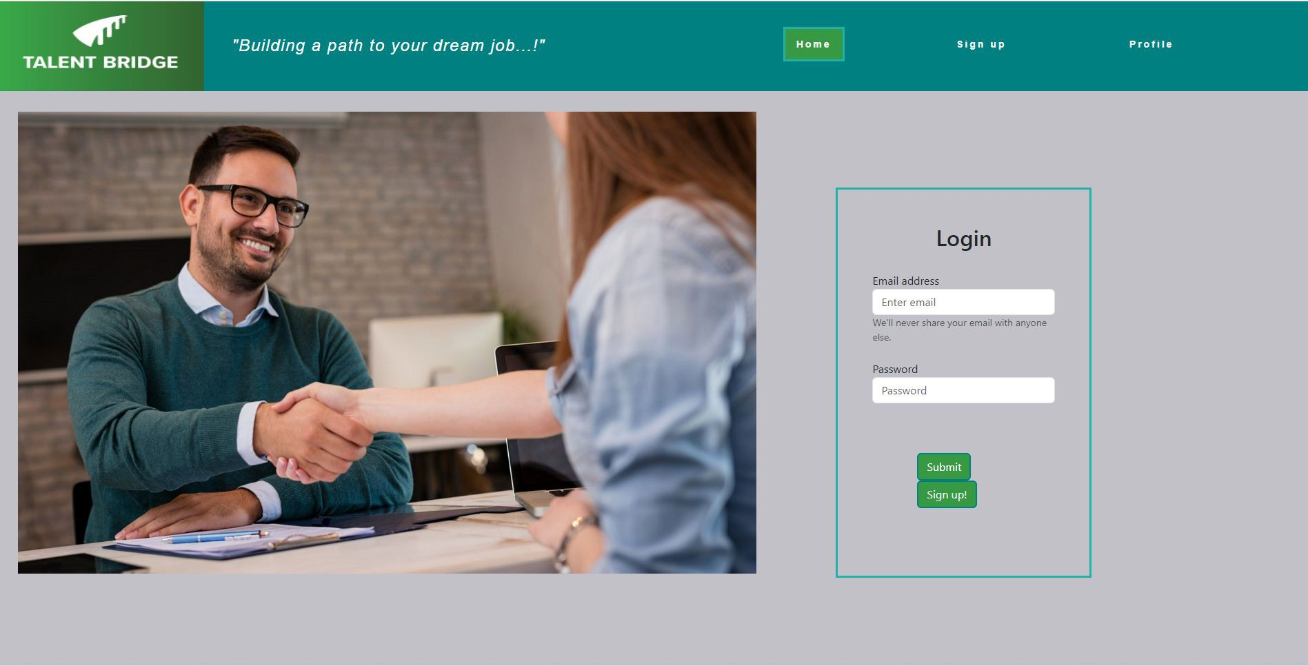](https://talent-bridge-app.herokuapp.com/)

## Directions for Future Development

* + **Enhancing User Experience: Expanding its database of jobs History of jobs applied**

**Number of applicants applied applied for a specific job**

* + **Personalization and Recommendations:**

**Personalize job recommendations New posted job notification**

* **Integration with Other Tools:**

**Upload and save resume Autofill registration form**

* **Expand scope of application:**

**Employers be able to search for candidates**

## Links

* + **https://talent-bridge-app.herokuapp.com/**
  + **https://github.com/GuyJiawei/TalentBridge-App**



**Thank you!**

**Any questions?**